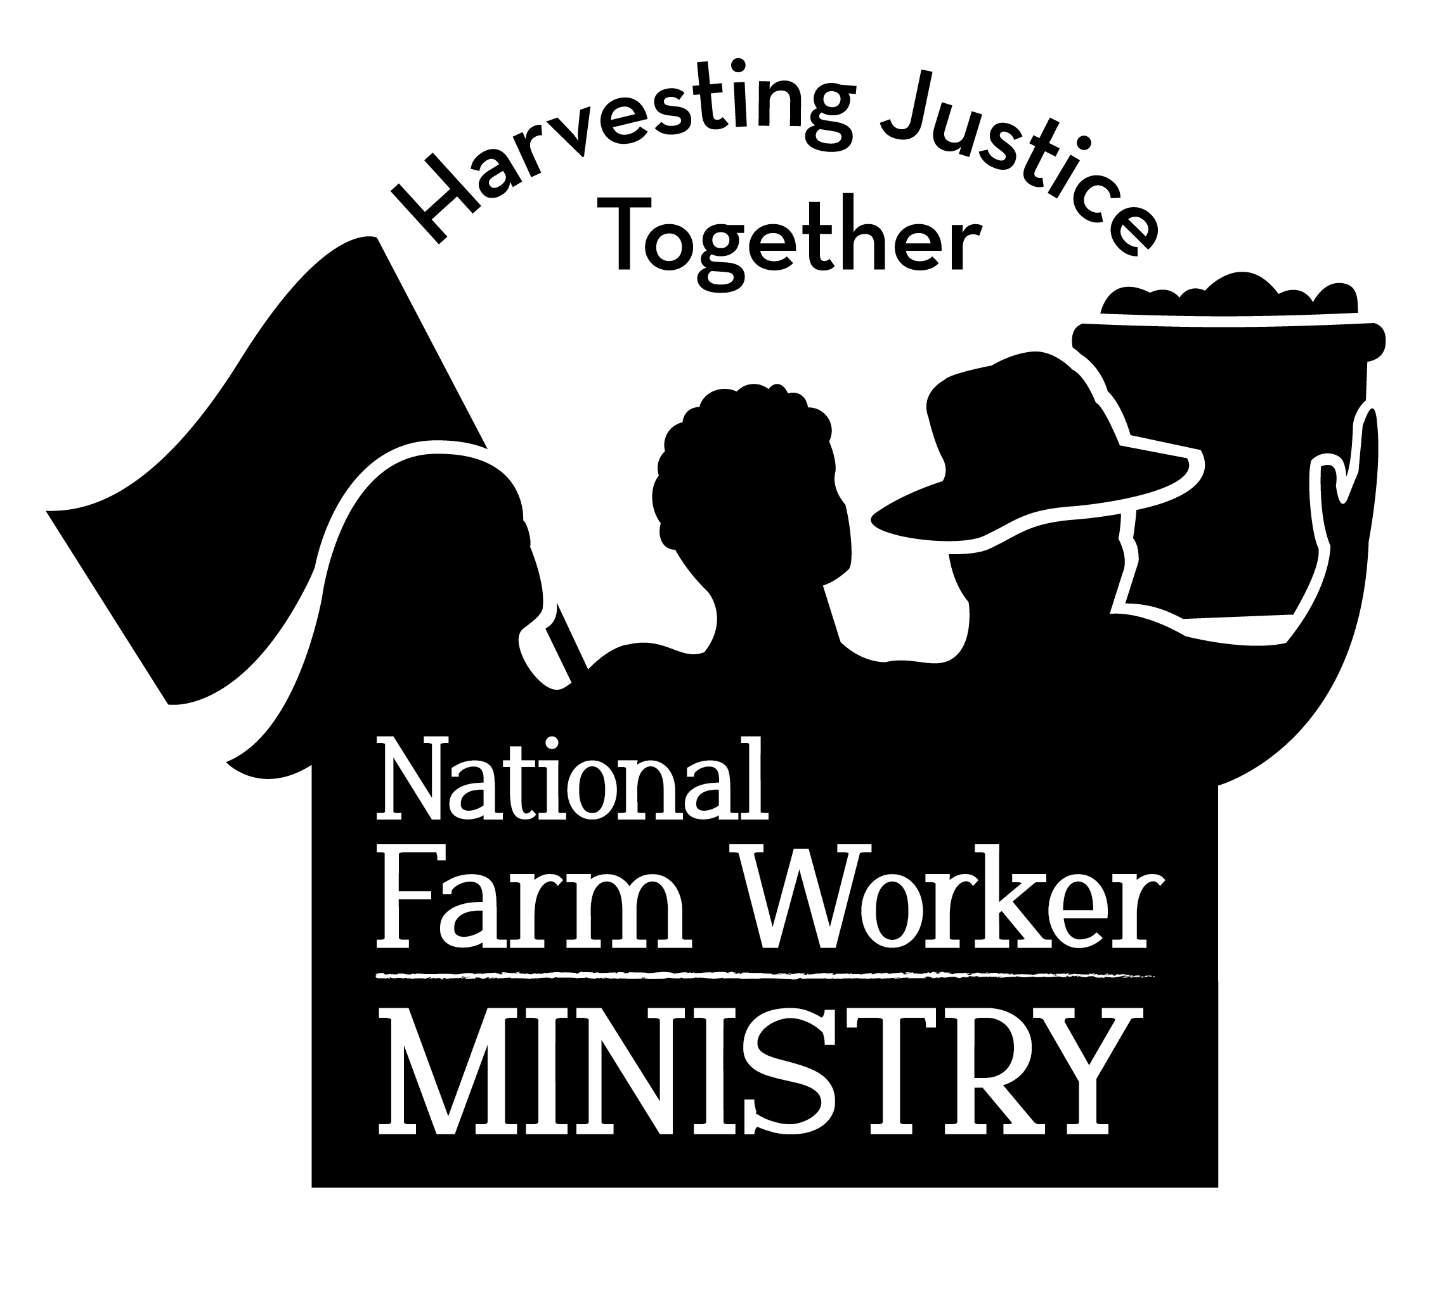

19 April 2023

Mike Vail, Chief Executive Officer

Hannaford Supermarkets  
145 Pleasant Hill Road

Scarborough, ME 04074

Dear Mr. Vail,

We are writing to urge Hannaford supermarkets to join the Milk with Dignity Program of Migrant Justice. In November of 2020, we sent a similar letter with no response from you, so we are asking, again, that you eliminate human rights abuses from your supply chain by becoming part of this effective monitoring program. As part of the faith community, we stand in solidarity with Migrant Justice in their work to support dairy workers.

As we have shared before, their Milk with Dignity Program is good for all. It benefits companies by certifying that dairy products are sourced free from human rights abuses. It benefits farmers by providing a premium during a time of economic challenge, it benefits workers by improving conditions and securing respect and safety on the farm. As people of faith, National Farm Worker Ministry believes this is crucial for seeking food justice in all parts of the U.S. food supply chain.

As a faith-based non-profit national organization that promotes farm worker rights, protections, and progress among communities of faith. Milk with Dignity aligns with our values in the way that the program gives farm workers oversight regarding their living and working conditions. We believe that, like everyone, farm workers deserve to live and work in safety and dignity with just compensation. By signing on to Milk with Dignity, Hannaford can be a leader in taking responsibility for the rights and well-being of workers in your supply chain.

Farm workers, consumers, non-farm people of faith, and all who value human rights over profits, are calling on you to join the program and ensure that farm workers’ human rights are protected. We urge you, join Milk with Dignity today. Please don’t let any more time pass. Talk with Migrant Justice and join this worker-driven socially responsible model of food certification.

We look forward to your response to this request,

Julie A. Taylor

Executive Director

Member Organizations

Alliance of Baptists

American Friends Service Committee FL

California Church Impact

Catholic Migrant Farmworker Network

Catholic Labor Network

Church of the Brethren

Church Women United in Illinois

Church Women United of

S. California & S. Nevada

Cumberland Presbyterian Church

Christian Church (Disciples of Christ)

The Episcopal Church

Evangelical Lutheran Church in America

Farm Worker Ministry Northwest

Franciscan Sisters of Little Falls

The Loretto Community

Methodist Federation for Social Action

NFWM Florida Advisory Group

Orange County Interfaith Committee

to Aid Farm Workers

Presbyterian Hunger Program PC (USA)

School Sisters of Notre Dame,

Shalom North America

Sisters of Charity, BVM

Sisters of Charity of Nazareth

Sisters of the Humility of Mary

Sisters of St. Francis of Assisi

Society of the Sacred Heart

United Church of Christ

Justice and Witness Ministries

The United Methodist Church General Board of Church and Society

The United Methodist Church General Board of Global Ministries

**438 N. Skinker Blvd. St. Louis, MO 63130 314-726-6470 www.nfwm.org**

**438 N. Skinker Blvd. St. Louis, MO 63130 314-726-6470 www.nfwm.org**

P. O. Box 10645 • Raleigh, NC • 27605 • 919-807-8707 • nfwm.org

**438 N. Skinker Blvd. St. Louis, MO 63130 314-726-6470 www.nfwm.org**

**438 N. Skinker Blvd. St. Louis, MO 63130 314-726-6470 www.nfwm.org**

Related to the National Council of Churches