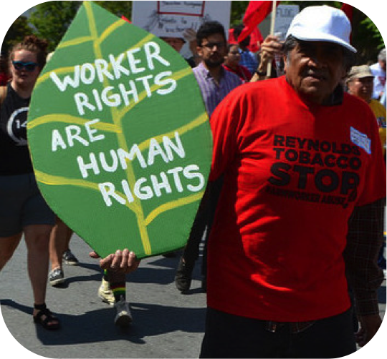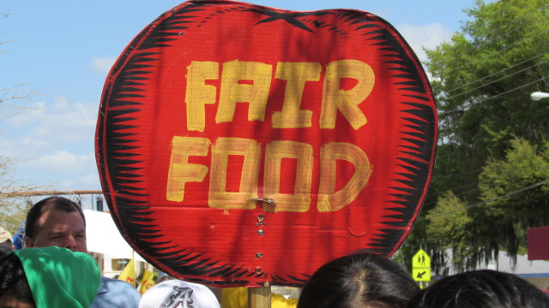

## **Did you eat today?**

## **Thank a farm worker!**

# The Harvest of Justice Season/Program is an opportunity to both **give thanks** for the farm workers across our nation for the season’s harvest and to **learn about the injustices** they face in our agricultural fields. A Harvest of Justice event only requires one hour of your time. The event will involve a humble meal, brief presentation, and prayers/reflections for farm workers. Contact [name of coordinator] to reserve your place [date] or to find out how to get involved!

Harvest of Justice is a program of the National Farm Worker Ministry (nfwm.org)

help support farm workers

* Harvest of Justice

### [Day]

[Date]

!