United Farm Workers of America Gerawan and Darigold Campaigns
The United Farm Workers strive to provide farm workers and other working people with the inspiration and tools to share in society's bounty.
*Recreated, in part, from www.ufw.org

National Farm Worker Ministry
112 Cox Ave, Raleigh, NC 27605
Tel 919.807.8707
www.nfwm.org
Contents

History of UFW 1
NFWM and UFW 2
Gerawan Campaign Timeline and Victories 3
Darigold Campaign Timeline and Victories 4-5
Farm Worker Stories 6
Gerawan Campaign Talking Points 7
Darigold Campaign Talking Points 8
How You Can Support UFW Campaigns 9
Faith and Farm Workers 10

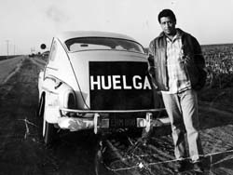
History of UFW
For more than a century farm workers had been denied a decent life in the fields and communities of California's agricultural valleys. Essential to the state's biggest industry, but only so long as they remained exploited and submissive, farm workers tried but failed many times to organize the giant agro-business farms that most observers considered it a hopeless task. By the early 1960's, things were beginning to change . Within fifteen years, more than 50,000 farm workers were protected by union contracts.
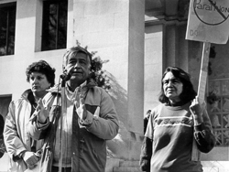
Founded in 1962 by Cesar Chavez, the United Farm Workers of America is the nation's first successful and largest farm workers union currently active in 10 states. The UFW continues to organize in major agricultural industries across the nation. Recent years have witnessed dozens of key UFW union contract victories, among them the largest strawberry, rose, winery and mushroom firms in California and the nation. 75 percent of California's mushroom industry is now under union contract. In 2007, the United Farm Workers signed its first contract with Salinas, Calif.-based D'Arrigo Bros., California's third-largest vegetable company. The agreement covers 1,800 farm workers in the Salinas and Imperial valleys. The UFW signed a contract, also in 2007, with Three Mile Canyon Farms—America's largest dairy—and the first major union contract protecting farm workers in Oregon. They soon signed up another nearby dairy, Willow Creek. Many recent UFW-sponsored laws and regulations aid farm workers. For example, in California, the first state regulation in the U.S. prevents further heat deaths of farm workers. The UFW is also pushing its historic bipartisan immigration reform bill.

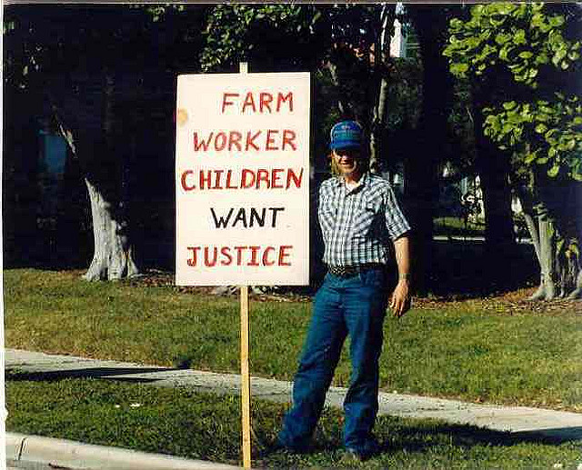
NFWM and UFW
NFWM and UFW have a long and enriching history together. NFWM began in 1920 as a ministry of charity and service, providing food, clothing and day care to the farm workers. When United Farm Workers founder Cesar Chavez began organizing in the 1960′s, he called on the religious community to change its emphasis from charity to justice. NFWM became the vehicle for people of faith to respond to that call and has continued in solidarity with UFW throughout its history.

Key Historic NFWM Actions in Support of UFW:
-1965-1966: UFW and NFWM begin a long history of partnership in support of farm worker justice when Cesar Chavez calls on faith communities to move from charity to advocacy.
-1960’s-1970’s: NFWM stands with UFW and Cesar Chavez through boycotts of major California table grape growers including Giumarra Vineyards and DiGiorgio Fruit Corp.
-After the victorious signing of union contracts by California grape growers in 1970, UFW called on allies, including NFWM, to support a national boycott of non-union lettuce.
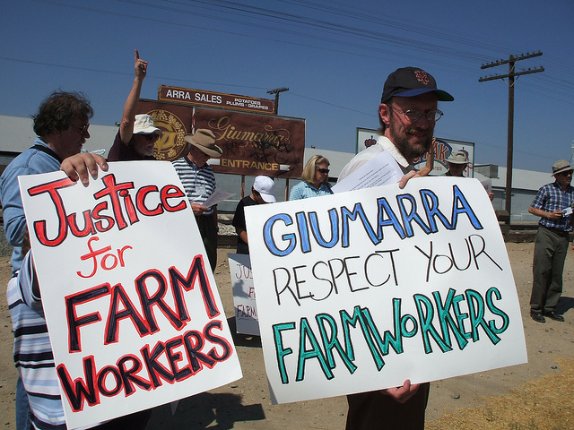
-In the 1980’s, led by UFW through the “Grapes of Wrath” Campaign, NFWM educated thousands of people of faith about the dangers of pesticides to farm workers and their children.
-Even after Cesar Chavez’s death in 1993, NFWM remained untiring supporters of UFW. From the 1990’s through 2000’s, NFWM has mobilized, educated and equipped people of faith in support of UFW campaigns and boycotts including immigration reform, the Darigold dairy campaign, Gerawan produce, and pesticide issues.
-Today, UFW is determinedly working on the Gerawan Campaign in support of stone fruit farm workers and the Darigold Campaign in support of dairy farm workers in the Pacific Northwest. NFWM has been a key player in these campaigns by providing an unwavering faith presence in actions, calls to partners in support of sign-on letters, and education to communities across the nation on the struggles of West Coast farm workers.

Gerawan Campaign Timeline and Victories
- May 4, 1990 — In a drive led by Cesar Chavez, the United Farm Workers of America intervenes in the Gerawan Farming Inc. union representation election, organizing workers and demonstrating enough support to get on the ballot. After another union, the Independent Union of Agricultural Workers/International Brotherhood of Painters and Allied Trades, AFL-CIO initially files for an election at the huge Fresno-based grape and tree fruit company. Gerawan insists on including its packinghouse workers in the balloting in an effort to swing the election against the unions.

- May 10, 1990 — The state of California (ALRB general counsel) accuses Gerawan of illegally laying off farm workers in 32 crews in order to prevent the workers from voting for the UFW, all in an effort to affect the outcome of election. Gerawan is later ordered to pay all the laid-off workers lost wages with interest to make them whole for the economic losses they suffered as a result of unlawful Gerawan’s actions. (ALRB case 90-CE-15-VI)

- July 21, 1992 — Cesar Chavez sends a letter to Gerawan requesting negotiations.

- August 13, 1992 — Gerawan agrees to negotiate, but then never makes a legal contract proposal.

- December 30, 1992 — Gerawan is found guilty by the state of California (ALRB) of closing down six farm labor camps in retaliation for workers’ support of the UFW, and the company is ordered to compensate workers for their loss of housing.

- November 22, 1994 — UFW Central Valley Regional Manager Tanis Ybarra submits the comprehensive bargaining proposal to Gerawan and proposes ground rules for the negotiations. Shortly thereafter, the UFW’s Ybarra meets with the company attorney and Mike Gerawan, taking them through the union bargaining proposal. The company agrees to prepare a counter-proposal. It is never received.

- January 17 - July 29, 2013 — Despite numerous negotiating sessions, Gerawan refuses to agree to a collective bargaining agreement with the union.

- March 29, 2013 — The UFW files for Mandatory Mediation under provisions of the 2002 binding mediation law.

- November 19, 2013 — The Gerawan workers’ long-awaited union contract is finalized by the ALRB, but the company refuses to implement it in violation of the law.

- April 9, 2014 — ALRB General Counsel takes Gerawan to court for violating the law and refusing to implement the collective bargaining agreement ordered by the State of California.

Darigold Campaign Timeline and Victories
- On June 14th, 2011, a court ordered the Ruby Ridge Dairy to pay five former Ruby Ridge workers $50,000 after they brought a litigation against Ruby Ridge for a variety of reasons, among them failure to pay the entirety of due wages and wrongful termination. It was reported in September that Ruby Ridge had yet to pay a single dime owed. Darigold is a large cooperative that markets the milk that Ruby Ridge produces under their brand.

- On October 10th, 2012, the United Farm Workers responded to Ruby Ridge’s failure by rallying in front of Darigold’s Seattle headquarters. Close to 200 people gathered in protest. Darigold refused to take responsibility for what Ruby Ridge did. In the absence of negotiation, security guards showed up to escort the protestors from the premises.

- In September of 2013, DeRuyter Brothers, a milk supplier for Darigold, threatened its workers with bullets, stole their wages, and gave them no alternative but to eat lunch while milking cows in unsanitary conditions. While many people emailed Darigold’s CEO, Jim Wegner, about this situation, Darigold failed to respond meaningfully or to take steps to remedy the problem. The following month, people of Mensonides Dairy, another milk supplier to Darigold were made aware. Several of their workers had complained of wage theft, not getting lunch or rest breaks, and not receiving adequate water to drink.

- On January 16th, 2014, dozens of farm workers for Darigold were joined by members of Farm to Family Coalition and other supporters for a third on-site protest at the Darigold headquarters in Seattle. Until this point, Darigold had failed to remedy any of the injustices that had gone on at their suppliers’ sites including wage theft, poor working conditions, unsanitary restrooms, lack of rest or lunch breaks, lack of water, mistreatment on the job, unsanitary eating conditions, and other worker abuses.

- On March 2nd, 2014, dozens of dairy workers, Oregon Farm Worker Ministry members, students, and supporters marched over two miles to Darigold’s Portland plant to deliver an online petition signed by thousands of concerned employees, supporters, and consumers, demanding the dairy brand take immediate action to resolve labor abuses at Darigold’s factory dairy farms.

- On May 4th, 2014, dairy workers, National Farm Worker Ministry members, Boise State University students, and supporters gathered to rally in front of the Idaho Capitol State Building in Boise, ID to demand that Darigold take immediate action in resolving labor abuses at their factory dairy farms.

- On May 8th, 2014, the Humane Society of the United States took a stand alongside the United Farm Workers in denouncing the abuses of both farm workers and farm animals at the factory dairy farms employed by Darigold. They issued a statement accusing employers of treating both workers and animals as “expendable commodities,” condemning their cruelty and calling for respect and dignity to be shown toward all living beings.

- On May 19th, 2014, the United Farm Workers released nauseating photos of animal cruelty along with a statement condemning such conditions as inhumane toward the cows and dangerous to the health of those who drink the milk.

- In May of 2014, a lawsuit was filed against Darigold for misleading marketing claims, accusing Darigold of misrepresenting the treatment of their farm workers and animals.

- On June 3rd, 2014, in response to Darigold’s dubious claim that the released photos do not represent current conditions, the United Farm Workers released even newer photos along with up-to-date documentation from current workers.

- On June 30th, 2014, a delegation of Darigold dairy workers and their supporters, including Oregon Farm Worker Ministry activists, gathered to meet personally with Lynn Gust, the CEO of Fred Myer, at the Fred Myer headquarters in Portland, demanding an end to employee abuse and animal cruelty. (Fred Myer sells a variety of Darigold products.) However, they were refused that meeting, told to leave the property, and the police were called. With more than 10,000 signatures in hand petitioning a response, the supporters resolutely remained on the public sidewalk in front of company headquarters. The company then agreed to meet the next day.

- On July 1st, 2014, a smaller delegation of dairy workers and the UFW met with Fred Myer. The workers spoke about their personal experiences at each dairy, including worker rights abuses and dangerous working conditions and injuries. Fred Myer agreed to contact Darigold to look into the issue further and committed to being back in touch.

Farm Worker Stories
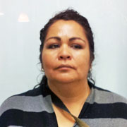

Guadalupe Martinez
Before the UFW came to Gerawan, in past years if you got sick from the heat, all of the supervisors would intimidate you, telling you they were going to lay you off. If you didn’t work fast enough, they would call the ticket person to give you a ticket and to pressure you. The women that were pregnant in my crew were afraid to report if they felt sick because the supervisor would send them home and would not recall them the next harvest season. We received a lot of pressure from our supervisor, threatening us that the other crews were leaving us, for us to hurry. The scissors they would give us no longer were sharp and were loose, and as a consequence we would hurt our hands. We would get blisters in our hands from trying to apply pressure. Also for one bad or rotten grape, they would stop you, even if it was 8am. They did not care if you had to pay transportation or babysitting.
This season, thanks to the UFW, there have been many changes. They no longer stop us and the wheelbarrows are ready in the fields, loaded with materials. My coworkers work more comfortably and no longer receive tickets, the supervisors don’t stop us early and there is less pressure. We have a voice in the field because we now have the backing of the UFW. All of these changes have not only benefitted us as workers but also our own families.
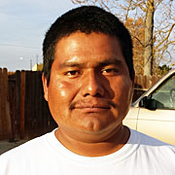
Fidel Garcia
I have worked for Gerawan Farming “La Prima” since 2004 and I see the changes since the Union came to the company. First, they raised the hourly wage to $10 when we were earning $9 and that has already benefitted me and my family. Now they treat us better and they don’t pressure us as much as before when they used to practically be behind us and when there was somebody who wouldn’t meet production or was a bit slower and would fall behind, all you would hear was “Go faster” and that worker would not return to work. They wouldn’t tell him anything. His ride would just not pick him up the next morning. This didn’t seem fair to me for them to do that. Now it is different. Because the Union is here, the supervisors treat us better. Now they don’t pressure us and now if you do something wrong they give you a ticket. But they don’t send you home anymore, you just get a ticket. Now the supervisor treats us with respect, they respect the people. Also now we can to go to the bathroom during work time when previously we could only go during lunch and sometimes we could not wait. Also in the harvest they now have all of our materials ready for us to work and without us having to fight for a wheelbarrow.

Gerawan Campaign Talking Points
- What is Gerawan Farming, Inc.?

Gerawan Farming is a family-owned grower of stone fruit in the Fresno area. Gerawan likes to brag of paying the highest wages and benefits in the industry, but they have broken contract by withholding wage increases that they had previously agreed to.

- What is the Gerawan Campaign?

The Gerawan Campaign is a movement led by the United Farm Workers (UFW) to bargain and negotiate with Gerawan for higher wages and better benefits. Although Dan Gerawan agreed to a contract that would enforce a wage increase, he has consistently refused to implement it, thus owing his farm workers thousands of dollars in unpaid debt.

- What has Gerawan done wrong and what has been done about it?

Gerawan has repeatedly intimidated its workers in an unlawful effort to prevent them from forming unions and advocating for their rights. On November 19th, 2013, the Gerawan workers’ long-awaited union contract was finalized by the ALRB. However, Gerawan continued to violate the law by refusing to implement that contract. As a result, on April 9th, 2014, ALRB General Counsel took Gerawan to court for violating the law and refusing to implement the collective bargaining agreement ordered by the State of California. As a result, Dan Gerawan owes a large debt to his workers.

Gerawan has repeatedly talked the talk without walking the walk. On August 13th, 1992, Gerawan responded to Cesar Chavez’s letter requesting negotiations by agreeing to negotiate. Nevertheless, Gerawan did not proceed to make a legal contract proposal.

On December 30th, 1992, Gerawan was found guilty by the State of California (ALRB) of closing down six farm labor camps in retaliation for workers’ support of the UFW. The company was thus ordered to compensate workers for their loss of housing.

- What can I do about it?
Gerawan sells their produce to Walmart under the brand name Prima. While UFW has spoken with Walmart about holding Prima accountable, they have not acted in favor of Prima workers. You can contact Walmart at the following link, urging Walmart to take action against Prima: http://action.ufw.org/page/speakout/walmart_prima

Darigold Campaign Talking Points
- What is Darigold, Inc.?

Darigold is a dairy agricultural marketing cooperative based out of Seattle, WA. They employ a variety of dairy factory farms, producing milk, butter, sour cream, cottage cheese, whipping cream, creamers, refuel, and yogurt. While they market these products with a clean aesthetic, the reality at the farms is very different.

- What is the Darigold Campaign?

The Darigold Campaign is a movement spearheaded by mistreated farm workers and the United Farm Workers in responses to injustices committed against these workers at the dairy factory farms that supply the milk sold through Darigold. Farm workers and their supporters have consistently protested human and animal abuses over the past few years without anything being done to remedy it.

- What has Darigold done wrong and what has been done about it?

Darigold has stubbornly refused to respond to the abuses committed by the employers of their dairy factory farms against their workers and animals. The litany of abuses includes unsanitary working conditions, withholding due wages while never paying them, failing to give workers necessary rest and lunch breaks, unsanitary eating conditions, wrongful termination, lack of water for hydration, neglect of injured animals, and other forms of mistreatment.

Multiple times from 2011 until the present, workers and their supporters have submitted petitions, filed lawsuits, rallied in front of company headquarters, and protested in hopes of getting Darigold to respond to the injustices committed against their farm workers and animals at their contract farms. Although Darigold has failed to respond in a meaningful way or to remedy the wrongs being done under them, Fred Myer—a chain of superstores who buy from Darigold—agreed to meet with a small delegation of farm workers and members of the United Farm Workers on July 1st, 2014. Fred Myer stated it would contact Darigold for further investigation and get back in touch.

- What can I do about it?

You can use the resources at http://action.ufw.org/page/s/milk614?source=web to tell your local store manager that you don’t want to buy milk from the cows that Darigold’s factory dairy farms have mistreated.

How You Can Support UFW Campaigns
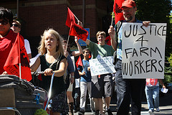
The United Farm Workers of America were in the forefront of the farm worker movement and continue to be a fierce participant in the fight for justice for US agricultural workers. The support of UFW by NFWM and its constituents has been tireless. However, the fight for justice is not a sprint, it is a marathon. UFW continues to need our solidarity in both the Gerawan and Darigold Campaigns.
-EQUIP: Organize supporters to email Darigold purchaser, Fred Meyer Stores, and inform them about the abuses occurring to both farm workers and animals on Darigold farms. Find a sample letter at http://action.ufw.org/page/speakout/milk1?js=false.
-EDUCATE: Take the Darigold or Gerawan campaigns talking points (Pages 5-6) and educate your community about the importance of justice for farm workers. Host a house party, speak to your local church congregation or focus on farm worker campaigns for your Vacation Bible School curriculum.
-MOBILIZE: Participate in an action in front of your local Walmart. Walmart is a major purchaser of Gerawan (also known as Prima) brand produce. They have the responsibility to address the abuses occurring within their supply chain. Take this flyer (http://www.ufw.org/pdf/walmartflyer.pdf) and mobilize others to support farm worker rights! Check out www.nfwm.org to stay up-to-date on UFW actions occurring in your community.

Faith and Farm Workers
Since the days of Cesar Chavez and the birth of the United Farm Workers, the faith community and the farm worker movement have been intertwined. There is a clear link between our calling as leaders of faith and the need to support justice for the dispossessed men, women and children who harvest our food. For years the United Farm Workers of America have been joined by faith leaders in the fight for justice and equity. For example, the National Council of Churches and National Farm Worker Ministry both supported UFW in urging local congregations to sign letters to Dan Gerawan requesting higher wages and better benefits for farm workers. The combined voices of people of faith is a wave of justice that cannot be stopped. We have the responsibility to stand up to inequalities and not turn a blind eye.
Without the religious support it would have been impossible to win our campaigns.
-Arturo Rodriguez, President, United Farm Workers.

When everyone else said no, that we couldn’t change companies and organize farm workers, [the faith community] said yes. Without the church, FLOC would not exist.
-President Baldemar Velasquez, Farm Labor Organizing Committee

