Farm Labor Organizing Committee Reynolds Tobacco Campaign
The Farm Labor Organizing Committee is called upon to challenge the deplorable conditions of the broader workforce that remains voiceless, powerless, and invisible to mainstream America.
*Recreated, in part, from www.floc.com

National Farm Worker Ministry
112 Cox Ave, Suite 208 Raleigh, NC 27605
Tel 919.807.8707
www.nfwm.org
Contents
History of FLOC 1
NFWM and FLOC 2
Campaign Timeline and Victories 3-4
Farm Worker Stories_____________________________________________________________________________________ 5
Reynolds Tobacco Campaign Talking Points 6-7
How you can support the Reynolds Tobacco Campaign 8
Faith and Farm Workers 9

History of FLOC
FLOC began in the mid-1960s when Baldemar Velásquez convinced a small group of migrant farm workers in northwest Ohio to come together for their common good. As numbers grew, together they mobilized in a crucial fight against the mechanization of migrant worker jobs in a boycott on Campbell Soup Company, even as they faced opposition from the American Federation of Labor and Congress of Industrial Organizations. Initial successes generated strong reactions in the agricultural industry that has been structured to benefit those at the top while exploiting laborers at the bottom. It took several years for FLOC to build a base among farm workers in the area. Since then, FLOC has built a membership of tens of thousands of migrant farm workers by incorporating two key principles:
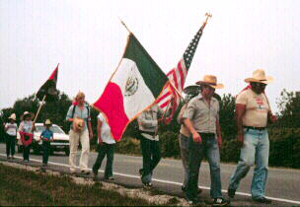
- Farm workers need a voice in the decisions that affect them: allowing workers to form a union and collectively bargain with their employer is the only way to address the huge imbalance of power and provide an effective structure for self-determination.
- Bring all parties to the table to address industry wide problems: large agricultural corporations have created a supply chain that enriches its executives at the expense of those who work in the fields. These corporations have the wealth and power to change the harsh realities that many farm workers face. FLOC seeks a structure where all those in the supply chain work together to solve problems: corporations, growers, and farm workers.

Through the many successes of FLOC, conditions of members have changed dramatically over the years. Not only have wages increased, but housing and other conditions have been improved. The greatest improvement, though, is that workers have a direct voice in their conditions through collective bargaining agreements that include an effective process for resolving grievances and problems. The movement continues to grow by building a strong popular base of supporters interested in justice. Corporations have tremendous economic and political power, but millions of people who mobilize in support of justice can collectively tip the balance of power to benefit farm workers.
Today FLOC continues to mobilize farm workers for social justice through assisting community organizing among groups such as Fuerza Y Libertad, the Northwest Ohio Immigration Forum, and—for more than 10 years—a Mobile Health Clinic through a partnership with the Campaign for Migrant Worker Justice.

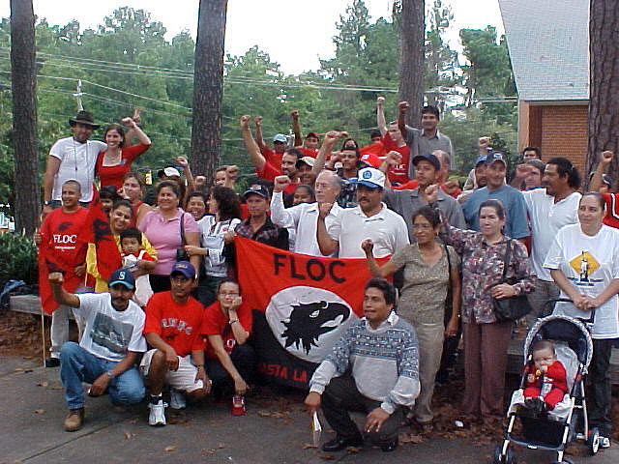
NFWM and FLOC
FLOC President Baldemar Velásquez called on the backing of faith communities to support the Campbell Soup Boycott in the late 1970’s and early 1980’s. NFWM was there to answer that call and has been a steadfast partner in justice from the beginning.

Key Historic NFWM Actions in Support of FLOC:
-In the late 1970’s and early 1980’s, NFWM mobilized people of faith to support FLOC’s call to boycott Campbell Soup and bring awareness to the dismal working and living conditions of tomato and pickle farm workers in the US.
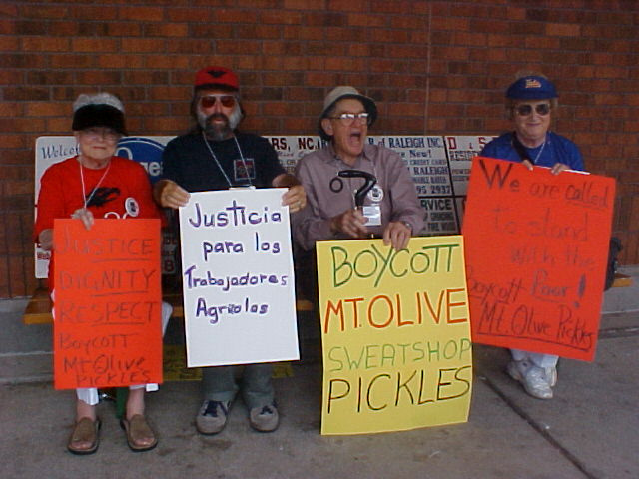
-August of 1983, President Velásquez, joined by NFWM and Cesar Chavez, led a 560-mile march from Toledo, OH to Camden, NJ where the Campbell Soup headquarters are located.
-After the 1986 victory of the Campbell Soup boycott, President Velásquez again called on NFWM to mobilize with FLOC and support a boycott on the North Carolina-based Mt. Olive Pickles.
-In 2006, FLOC launched the Reynolds American Tobacco Campaign to negotiate better conditions for tobacco farm workers in the Southeast. This campaign is a multi-tiered, complex campaign designed for holding large, corporate purchasers responsible for the living and working situations of workers in their supply chain.
-With the formation of the NFWM-YAYA network in Orlando came a new generation of farm worker supporters. NFWM-YAYA provides consistent solidarity at FLOC rallies and events. They also do actions at WAWA stores in Florida, demanding justice for tobacco farm workers.
-Today, the Reynolds American Tobacco Campaign is making headway in an industry grounded in oppression. NFWM maintains steadfast support of FLOC by mobilizing supporters for the past seven annual Reynolds Shareholders’ Meetings, participating in actions and rallies outside of stores within the Reynolds supply chain, and maintaining unwavering backing from our faith communities through letter writing and calls to corporate executives. NFWM also provides organizing and education support for FLOC’s 2014 Summer Sign-Up Campaign. This campaign has the lofty goal of signing up 5,000 new FLOC union card members over the 2014 summer months.

Campaign Timeline and Victories
- In 1978, President Velásquez led over 2,000 FLOC members on strike in Ohio, the largest in the agricultural history of the Midwest. They demanded union recognition and a multi-party bargaining agreement.

- The following year, in 1979, FLOC held its first constitutional convention as a labor union, and the workers voted to boycott Campbell Soup in their call for negotiations. FLOC struggled for eight years to win the first tri-party contract.

- In 1983, Baldemar led a 560-mile march of 100 farmworkers from Toledo, Ohio to Campbell’s headquarters in Camden, New Jersey.

- The pressure of FLOC actions and the support of allies across the nation for the boycott eventually convinced Campbell Soup that the issue was not going away. In 1986, FLOC signed three-way contracts with Campbell Soup and its tomato and pickle grower associations in Ohio and Michigan.

- This victory was soon extended to Heinz and other major food-processing corporations in the Midwest as well as fresh-market producers. Under union contracts, some 8,000 workers—many who had worked under exploitive “share-cropping” arrangements—received employee status, and wages and benefits more than doubled.

- New housing in migrant camps and other conditions also significantly improved. Under grievance procedures established in the union contracts, FLOC workers also have a direct voice in their day-to-day working conditions and can file complaints without fear of retaliation.

- In 1998, FLOC began organizing farm workers in North Carolina, the other major region in the U.S. where pickles are produced. After organizing thousands of farm workers and a 5-year boycott of Mt. Olive Pickles, in 2003 FLOC won another three-way contract with Mount Olive and the North Carolina Growers Association. The North Carolina Growers Association represented workers not only involved with pickles, but also sweet potatoes, tobacco, Christmas trees, and other crops.

- These contracts also set labor history, not only by changing the agricultural system but also by bringing in H2A “guest workers” under union contracts. Formerly, these workers had little say in who employed them or in the conditions of their work. Now, through FLOC, they have their own voice and are directly involved in labor negotiations, grievance procedures, and building structures to address issues like transportation from their home areas in Mexico, health care, and immigration policies.

- In 2001, FLOC partnered with the United Farm Workers to file a lawsuit against the United States Department of Labor for ignoring wage requirements and failing to enforce the law on cucumber growers who were underpaying more than 30,000 guest workers.

- In 2005, FLOC and UFW won their lawsuit, and the noncompliant employers were finally forced to pay up—$1.4 million in compensation for the deductions illegally stolen from the salaries of North Carolina workers.

- In 2006, FLOC propelled forward with the Reynolds American Tobacco Campaign that organized tens of thousands of tobacco farm workers throughout North Carolina and the South while also calling on large tobacco companies to take responsibility for the human rights violations that were occurring in their supply chains.

- In 2012, on May 3, FLOC mobilized with several other organizations to disrupt a meeting of CEOs at R.J. Reynolds Headquarters and confront them about the crimes committed against tobacco farm workers. They demanded acknowledgment of these crimes and, ultimately, reform for providing relief to the suffering workers. R.J.R agreed to a meeting and FLOC took to the streets of Winston-Salem, NC to celebrate.

- In September of 2012 over 200 religious leaders signed a letter sent to Reynolds CEO and directors on behalf of tobacco farm workers. The letter calls on RAI to work with FLOC to develop a written agreement establishing a process guaranteeing freedom of association and collective bargaining for tobacco farm workers in the RAI supply chain.

- In April of 2014, FLOC announced a summer organizing campaign—“Respect, Recognition, Raise!”—intended to sign up 5,000 new union cardholders along the East Coast. Three important shareholders’ meetings have followed.

- On April 30th of 2014, FLOC President Baldemar Velasquez travelled to London, England to attend British American Tobacco’s (BAT) Annual General Meeting. As BAT represents 42% of Reynolds American and has five board members on the Reynolds Board, they represent an important stakeholder in the FLOC Reynolds Campaign. President Velasquez received confirmation from two members of the British Parliament that they have accepted his invitation to visit the fields in North Carolina this summer.

- On May 7th of 2014, Dr. Alvin Jackson, Pastor of Park Avenue Christian Church in New York City and Assistant Pastor for Outreach Rev. Luis-Alfredo Cartagena Zayas joined Michael Szpak from the AFL-CIO for the Philip Morris International (PMI) Annual Shareholders’ Meeting in New York. Unlike BAT, Philip Morris International in not a shareholder in Reynolds American. However, as the largest purchaser of tobacco products in the Southeast and fellow member of the FLPG, PMI holds great influence in the tobacco industry. PMI Chairman of the Board Louis C. Camilleri responded to requests urging responsibility to address human rights abuses by indicating that PMI would finally meet with FLOC.

- On May 8th of 2014, Reynolds American hosted their Annual Shareholders’ Meeting in Winston-Salem, NC. Dozens of FLOC supporters directed questions at RAI executives about everything from the ineffectiveness of the Keystone group to what, if anything, RAI is prepared to do to protect workers from retaliation during this summer sign-up campaign. Several times Reynolds Chairman Thomas Wajnert alluded to laws that protect farm workers and ensure them the right to organize. FLOC supporters proceeded to remind Chairman Wajnert that farm workers are excluded from many labor law protections including protection from retaliation for seeking remediation of grievances for union organizing.
- In July of 2014, nearly 500 religious leaders signed another letter sent to Reynolds CEO and directors on behalf of tobacco farm workers.

Farm Worker Stories

Testimony from FLOC workers
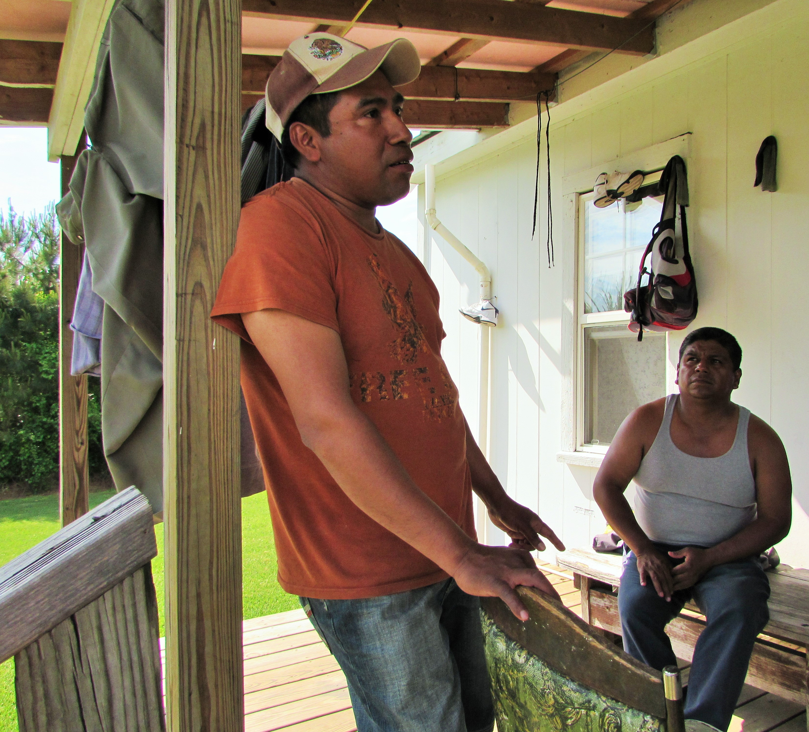
In the late 1990’s, Pasqual (left in adjacent image) came to the United States from Mexico in search of agricultural work and an opportunity to better his living conditions. He freely talks about the hardships endured in Mexico, including a severe lack of jobs, gang violence, and the overall corruption. When he first arrived in the United States, Pasqual began working in North Carolina and was assigned to a corrupt and abusive crew leader. He said, “My crew leader was very mean. He would yell at us and take our money. Things were bad.”
The next year, Pasqual met FLOC President Baldemar Velásquez. President Velásquez introduced Pasqual to the accomplishments of the union and the huge changes that having a voice in your own circumstances can facilitate. Pasqual said about FLOC, “the union has made so many things better. We can talk until the night comes about the abuses but I want to focus on what we have accomplished. Things are better and that is what I want people to remember. What [FLOC] is doing is working.”

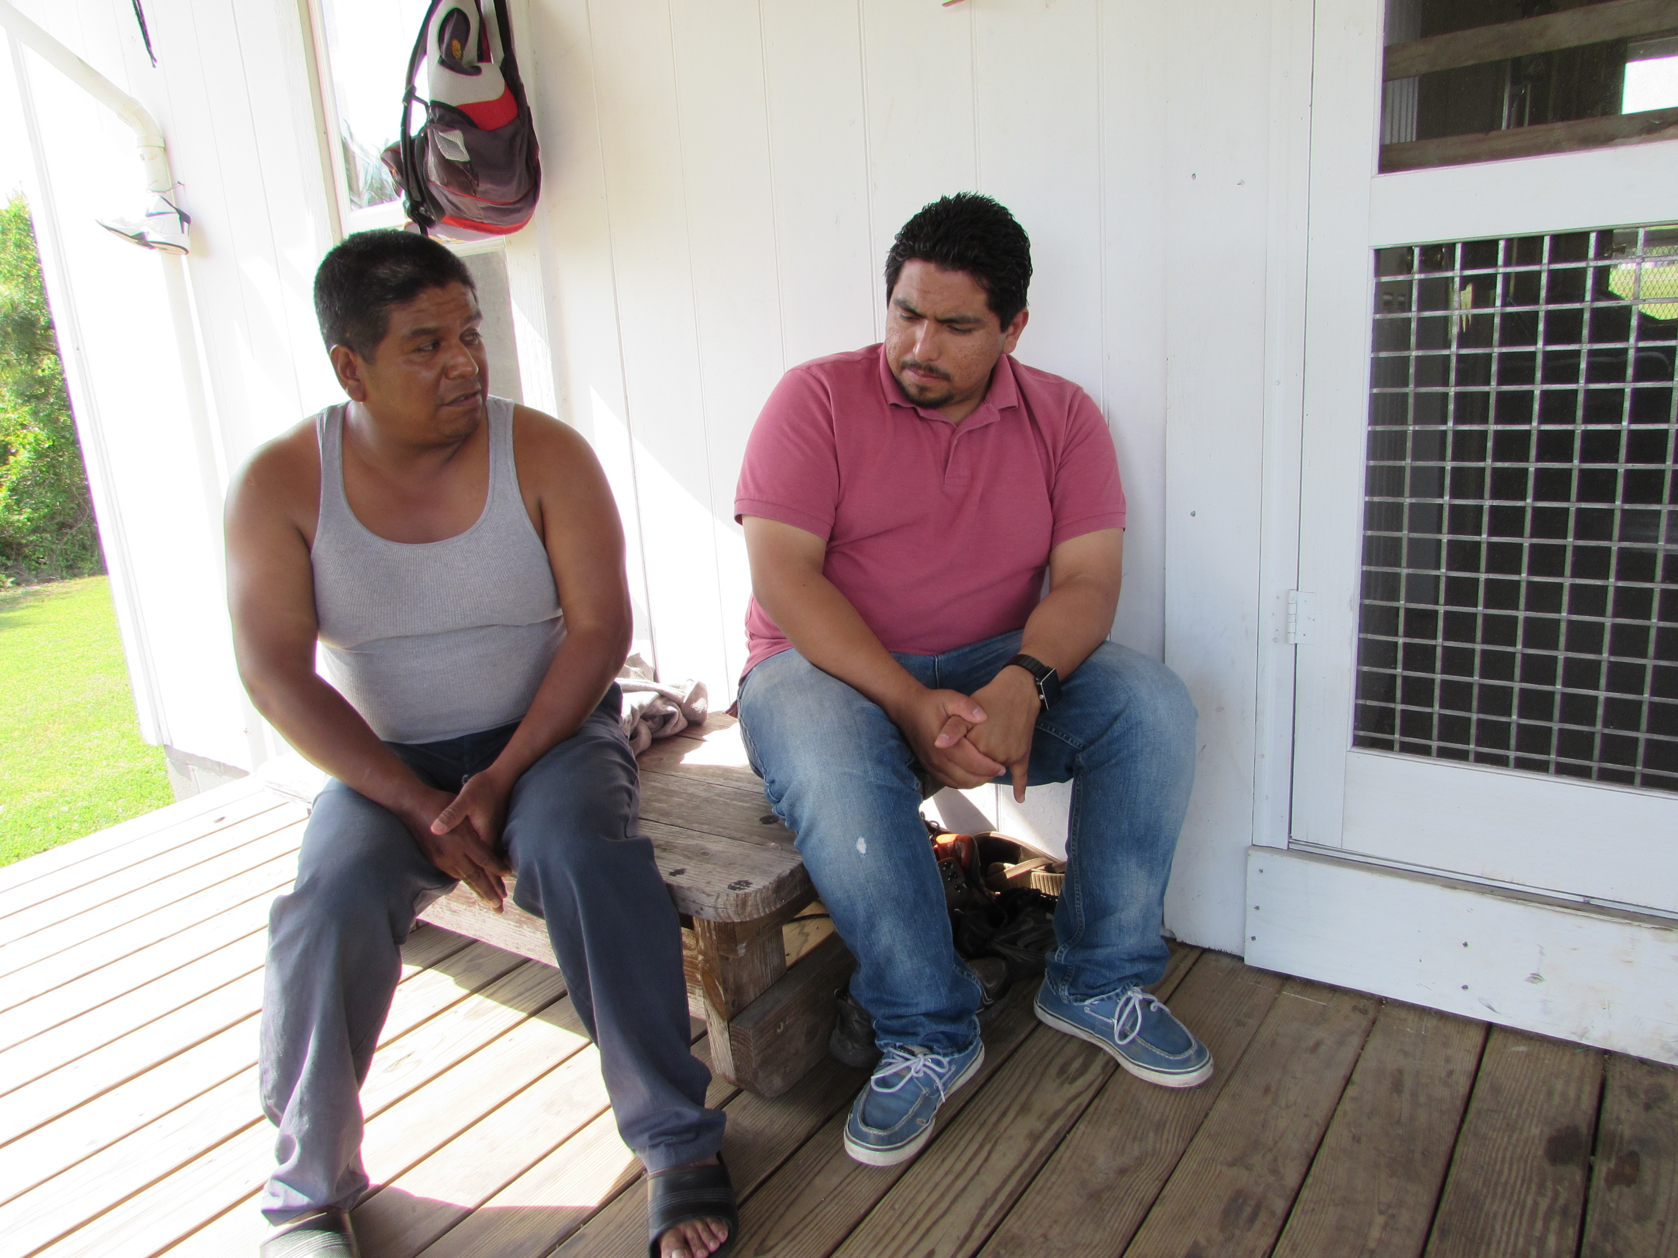
Raul (left in adjacent image) left his home in Mexico in 1996 for a job on a Georgia farm. When he arrived in Georgia, farm workers were being forced to hand over their passports and were threatened with being “blacklisted” from working in the United States if they did not comply. Raul refused to give up his passport and returned to Mexico without working that season. The next year he made his second trip to the United States, this time heading for a North Carolina tobacco field. President Baldemar Velásquez met him at the North Carolina Growers Association building and told him about FLOC. Although he was hesitant after his experience in Georgia, Raul said that he “liked what President Velásquez was saying,” and so he joined the union. Now, Raul is more than willing to participate in any FLOC action he can because he sees the strength in being part of FLOC. “If there is a march, a rally, or a picket, anywhere I am needed, I will be there!”

Reynolds American Tobacco Campaign Talking Points
- R.J. Reynolds is the second largest tobacco company in the U.S., responsible for one in every three cigarettes sold on the market.

- Farm workers employed by corporate giants in the tobacco industry suffer as victims of poverty, racism, harassment, nicotine poisoning, lethal pesticides, miserable housing in labor camps, and denial of basic human rights and labor protections.

- Tobacco farm workers are at great risk of heatstroke due to the following two factors: the body temperature-raising effects of nicotine on the farm worker and the lack of mandatory water breaks during long periods of labor out in the hot fields.

- Nine farm workers have died in North Carolina in the last decade. In a five-year period, seven died of heat-related illnesses.

- Nicotine poisoning causes Green Tobacco Sickness (GTS), characterized by nausea, vomiting, weakness, dizziness, and an occasional increase in blood pressure and heart rate.
- Tobacco workers are exposed to toxic pesticides on a daily basis. The consequences of exposure include reproductive problems, birth defects, Alzheimer’s, Diabetes, cancer, autism, and memory loss among other things.

- FLOC, the Farm Labor Organizing Committee, represents farm workers who pick tobacco under a collective bargaining agreement with the North Carolina Growers Association (NCGA) as well as farm workers in Michigan and Ohio.

- FLOC is working to hold RAI (Reynolds American Inc.) accountable to agreed upon rights for farmer workers including the freedom of association.

- According to the PMI Agricultural Labor Practices Code, farmers are required to recognize and respect workers’ rights to freedom of association and to bargain collectively.

- RAI does not directly employ tobacco farm workers. However, by contracting with growers, they influence the standards that directly impact the living and working conditions of tobacco farm workers.

- RAI has failed to implement the standards for human rights they have agreed to by not taking responsibility for the injustices committed by their contract growers.

Talking Points Continued:
They have also denied known exploitation of farm workers employed at their contract farms.

- On June 5, 2012, FLOC President Velásquez met with Mr. Martin Holmann III, RAI Executive Vice President and General Council, at FLOC headquarters in Toledo, OH. The meeting was for discussing ways that Reynolds can work towards ensuring safer and healthier conditions and the labor and human rights of tobacco farm workers in the supply chain. Such meetings were difficult to achieve.

- In September 2012, over 200 religious leaders signed a letter sent to Reynolds CEO and directors on behalf of tobacco farm workers. The letter calls on RAI to work with FLOC to develop a written agreement establishing a process guaranteeing freedom of association and collective bargaining for tobacco farm workers in the RAI supply chain. In this way, RAI would affirm the voices of the tobacco farm workers, address common concerns, identify and work toward eliminating abuses in the supply chain, and ultimately improve their living and working conditions.

- In April 2014, FLOC announced a summer organizing campaign called “Respect, Recognition, Raise!” This campaign aimed at signing up 5,000 new union cardholders along the East Coast. Since then, three significant shareholders’ meetings have followed.

- The first meeting was convened on April 40th in London, England between President Baldemar Velasquez and British American Tobacco (BAT). Baldemar was able to receive confirmation from two members of British Parliament that they had accepted his invitation to visit the fields in North Carolina this summer.

- The second meeting was convened on May 7th in New York City between religious leader Dr. Alvin Jackson and Philip Morris International (PMI). PMI Chairman of the Board Louis C. Camilleri agreed to meet with FLOC to discuss PMI’s responsibility in addressing human rights abuses.

- The third meeting was convened on May 8th in Winston-Salem, NC, involving FLOC supporters who directly questioned executives of Reynolds American. Chairman Wajnert repeatedly alluded to laws that protect farm workers and ensure them the right to organize, and FLOC supporters had to remind him that farm workers are excluded from many labor law protections including protection from retaliation for seeking remediation of grievances or union organizing.

- In July of 2014, two members of British Parliament accepted FLOC’s invitation to visit the fields in North Carolina. They were appalled at the living and working conditions. Also in July, another religious leaders letter was sent to RAI directors - this time with nearly 500 signatories.

How You Can Support the Reynolds American Tobacco Campaign
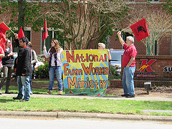
The Farm Labor Organizing Committee has seen valuable victories in its extensive history. These victories have allowed FLOC to become a competent and sustainable player in an industry with a long history of subjugating workers. There are a variety of ways in which individuals and organizations can show support for tobacco farm workers through the work of the Farm Labor Organizing Committee.
-EQUIP: Organize supporters to email Reynolds’ leadership team about the abuses in North Carolina tobacco fields. Pressure them to join in a conversation with FLOC and move forward in ending human rights abuses in the Southern United States. Find sample letters and resources at www.floc.com/wordpress/join-us.
-EDUCATE: Take the Reynolds American Tobacco Campaign talking points (Pages 5-6) and educate your community about the importance of justice for tobacco workers. Host a house party, speak to your local church congregation, or hand out flyers outside stores in Reynolds’ supply chain such as Kangaroo Express or WAWA’s.
-MOBILIZE: Participate in an action in front of your local Kangaroo Express or WAWA convenience store. These stores are in the Reynolds American Tobacco supply chain and have the responsibility to address the abuses occurring to tobacco farm workers. Plan to attend the annual Reynolds Shareholders’ Meeting each year in May, located in Winston-Salem, NC. The mobilization of FLOC allies for this meeting, and the rally that follows, is an important component to the Reynolds American Tobacco Campaign. Check out www.nfwm.org to stay up-to-date on FLOC actions occurring in your community.

Faith and Farm Workers
Since the days of Cesar Chavez and the birth of the United Farm Workers, the faith community and the farm worker movement have been intertwined. There is a clear link between our calling as leaders of faith and the need to support justice for the dispossessed men, women, and children who harvest our food. The combined voices of people of faith create a wave of justice that cannot be stopped. For seven years FLOC, faith leaders, and other community activists from coast to coast have banded together to pressure Reynolds American to address human rights abuses in their tobacco supply chain. As seven years is far too long to wait for justice, we have the responsibility to stand up to inequalities rather than turning a blind eye.
Without the religious support it would have been impossible to win our campaigns.
-Arturo Rodriguez, President, United Farm Workers

When everyone else said no—that we couldn’t change companies and organize farm workers—[the faith community] said yes. Without the church, FLOC would not exist.
-President Baldemar Velásquez, Farm Labor Organizing Committee

