Farmworker Association of Florida Campesinos’ Garden

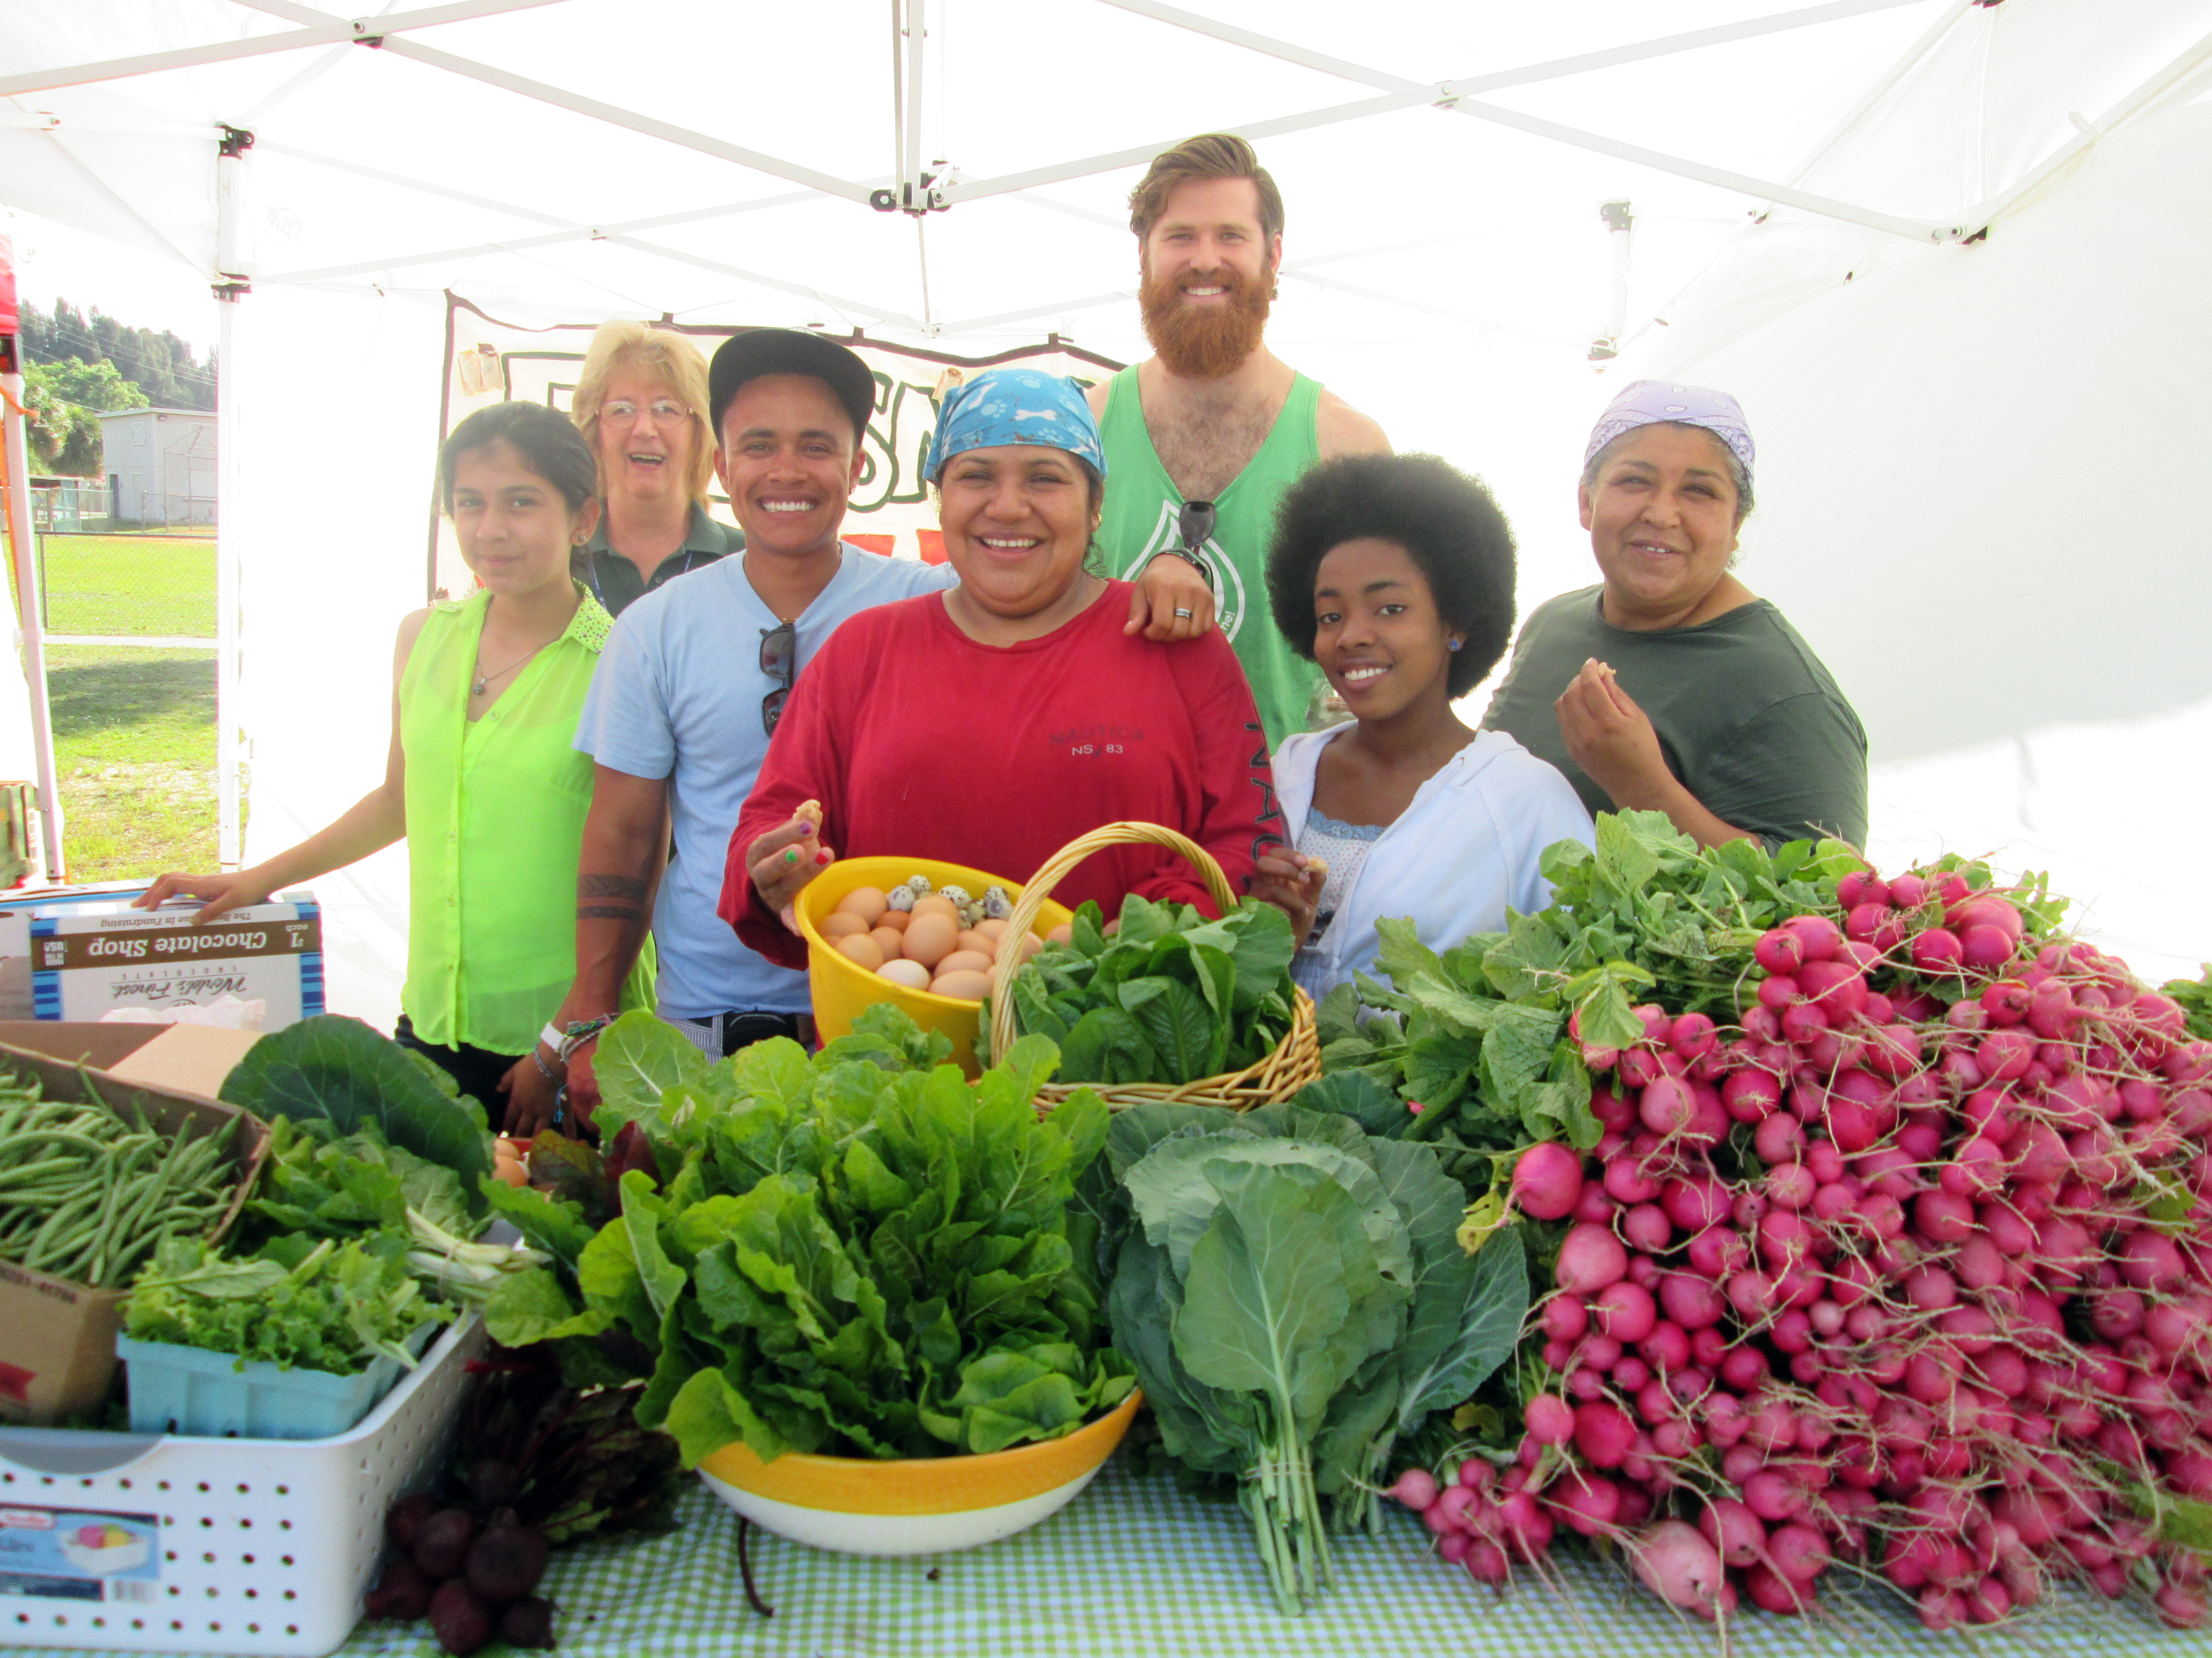
FWAF Campesinos’ Garden is an initiative to bring local, organic food to low-income and farmworker communities. The project started in Fellsmere, Florida with intentions of bringing it to all 5 areas (Apopka, Immokalee, Fellsmere, Homestead/Florida City, and Pierson) in which FWAF offices are located. The general plan is to replicate the garden and market model from Fellsmere to all other areas.

More on the Fellsmere Model:
After more than a year of planning and decision-making, in 2010, low-income community members in the citrus-growing region of Fellsmere, Florida, established a community garden run by-and-for primarily farmworker families. What began as an idea to use their growing knowledge to benefit their own families and community has grown into a much larger endeavor. Now known as the Campesinos’ Gardens, the model has evolved to include the following key elements:
- Rooted in agro-ecological principles – i.e. the garden strategy includes not only growing organically with the intention of feeding the low-income community, but also with intent to reclaim and share traditional growing knowledge in alignment with earth’s natural systems and cycles; to reconnect people to the health importance of eating real whole foods; to engage young people in connecting to their agricultural heritage; to source supplies locally when possible and with consciousness of ecological impact; and to build community through collective experiential and intergenerational learning that connects social, political, environmental, and historical issues to how our food is produced;
- Governed by a community decision-making committee of garden members, who are typically minority and low-income;
- Supported by local government through the provision of land and other resources;
- Supported by the local extension office and other local and national allies/resources; and
- Connected to the establishment and maintenance of a local farmers’ market accessible by the low-income community.

Fellsmere – has been growing for over 2 years in creating 2 sustainable plots where community members can grow food individually or in the community garden. Earlier this year, they expanded to selling the extra produce at their local Farmer’s Market allowing for a sustainable income to be spent for the garden (i.e., buying new seeds, renting a trailer to move, haul plants, etc.).

Homestead/Florida City – received an agreement signed earlier this year with the Florida City government for a convenient and large location (8 lots near their office). They have experienced a couple of cumbersome permitting processes and now have a fence built and electric connected. FWAF has a garden design plan and had their groundbreaking ceremony this past April. They plan to beginning planting in Fall of this year. So far 22 families are organized to be a part of the garden, which is in its beginning phases.

Pierson – has an agreement with the Town of Pierson for their garden site, which is about ½ an acre. So far 20 families are organized to be a part of the garden although no start-up activities have been planned.

Apopka and Immokalee – These two areas will be on hold until Homestead and Pierson have successfully started. One of the largest problems FWAF is experiencing in both areas is the need for funding for the project. Specifically with Apopka, since there is already a community garden in place, FWAF will determine whether it will be better to align themselves with the current community’s project goals related to food sovereignty and agro-ecology and low-income people’s access to organic food to work on boosting the current community members’ participation, or to establish a Campesinos’ Garden in Apopka. Immokalee is in need of a good coordinator for the work of the garden but is hoping to have this area figured out by 2015.

What to look for/Ways to support
- FWAF will be organizing an agro-ecology Encuentro (first in the U.S) in Jan 2015 with the Rural Coalition and La Via Campesina of North America. The point of the Encuento is to support the participation of farmworkers/small farmers in these areas in a co-learning environment to move forward the principles of agro-ecology and food sovereignty.
- FWAF is looking to raise funds for Tirso Moreno (General Coordinator of FWAF) and Yolanda Gomez (Fellsmere – FWAF organizer) to attend the Slow Food International’s Terre Madre event in Italy this upcoming October where they will present on the Florida farm workers and the Campesinos’ Gardens as a model project that engages farmworkers in organic production of food to benefit their families and communities.

