Coalition of Immokalee Workers Fair Food Program
The Coalition of Immokalee Workers (CIW) is a worker-based human rights organization recognized for its achievements in the fields of corporate social responsibility, community organizing, and sustainable food. The CIW is also an active player in the growing movement to end human trafficking due to its work to combat modern-day slavery and other labor abuses common in agriculture.
*Recreated, in part, from www.ciw-online.org

National Farm Worker Ministry
112 Cox Ave, Suite 208 Raleigh, NC 27605
Tel 919.807.8707
www.nfwm.org
Contents
History of CIW 1
NFWM and CIW 2
Campaign Timeline and Victories 3
Farm Worker Quotes 4
Fair Food Program Talking Points 5-6
How you can support the Fair Food Program 7
Faith and the Fair Food Program 8

History of CIW
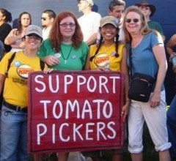
The Coalition of Immokalee Workers (CIW) formed in 1993 as a small group of workers who met to discuss how to better their community and their lives. Initially they met weekly in a room borrowed from a local church.

Combining three community-wide work stoppages with intense public pressure – including a month-long hunger strike by six members in 1998 and a historic 234-mile march from Ft. Myers to Orlando in 2000 – the CIW’s early organizing changed over twenty years of declining wages in the tomato industry.

By 1998, farm workers had won industry-wide raises of 13-25% and a new-found political and social respect from the outside world. Those raises brought the tomato picking piece rate back to pre-1980 levels, but wages remained below poverty level and continuing improvement was slow in coming.

While continuing to organize for fairer wages, the CIW also turned its attention to attacking involuntary servitude. Over the past 15 years, nine major investigations and federal prosecutions have freed over 1,200 Florida farm workers from captivity and forced labor, leading one US attorney to call these fields “ground zero for modern slavery.”

In 2001, having won some wage increases for Florida tomato pickers and investigated some of the country’s earliest cases of modern-day slavery, the CIW did an analysis of the industry to understand where the power to make systemic change resided. It became clear that the corporate food industry as a whole—companies such as current campaign targets Kroger, Publix, and Ahold USA—purchased a tremendous volume of fruits and vegetables, leveraging its buying power to demand the lowest possible prices from its suppliers, in turn exerting a powerful downward pressure on wages and working conditions in these suppliers’ operations.

From this realization, the Fair Food Program was born, providing CIW agency in the farm worker movement and social justice advocacy. The Fair Food Program functions as a covenant between the CIW and the Florida Tomato Growers. It aims at better wages, better working conditions, and higher standards through strengthened partnerships between workers, growers, and buyers. Taco Bell, McDonald’s, and Walmart have been persuaded to join the Program, only purchasing from growers that comply with it. In this way, CIW has had a large impact already.

NFWM and CIW
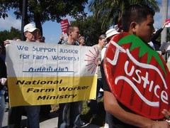
Since the inception of CIW, the National Farm Worker Ministry has played an active role in propelling the Coalition forward in the farm worker movement. In the early days, CIW called on NFWM to provide guidance and organizing expertise to the workers. Now, NFWM serves as a vehicle to bring a face of solidarity to actions across the nation in support of the Fair Food Program.

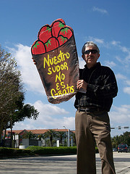
Key Historic NFWM Actions in Support of CIW:
-NFWM participated in CIW’s historic 234-mile march from Ft. Myers to Orlando in 2000.
-In the early-2000’s, NFWM mobilized people of faith to support CIW’s boycott of Taco Bell, the first farm worker boycott of a major fast food company.
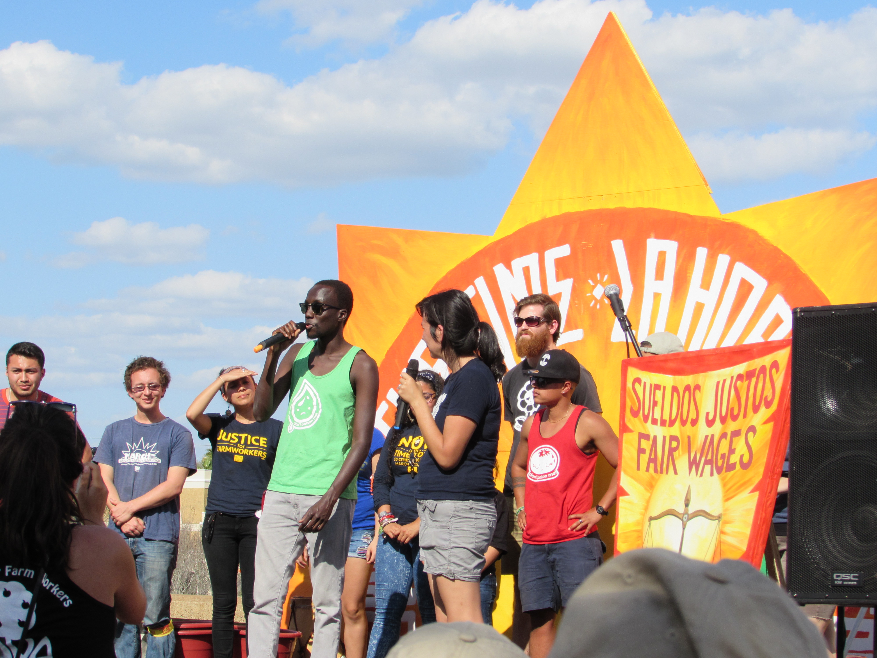
-CIW carried their success with Taco Bell over to a landmark campaign against the largest fast food company in the world, McDonald’s. NFWM continued to be stalwart beside CIW, organizing actions and pickets outside McDonald’s restaurants across the nation.
-Once McDonald’s and CIW reached an agreement in 2007, the flow of fast food restaurants and supermarkets who would sign on to the Fair Food Program was monumental. NFWM was unrelenting in organizing efforts for CIW, calling on supporters to pressure companies such as Subway, Whole Foods and Chipotle Mexican Grill.
-With the formation of the NFWM-YAYA network in Orlando came a new generation of farm worker supporters who are also geographically convenient for CIW actions. NFWM-YAYA provides consistent solidarity at CIW rallies and events.
-In 2014 NFWM mobilized supporters from Ohio to Florida in support of CIW’s “Now is the Time” Tour.
-Today, the Fair Food Program has become a prominent player in the farm worker movement but some companies are still holding out. NFWM maintains steadfast support of CIW through actions in front of Wendy’s restaurants, Publix Supermarkets, and Ahold, parent company to supermarkets Stop & Shop and Giant, and Kroger.

Campaign Timeline and Victories
- In the early 2000’s, CIW initiated a national boycott of Taco Bell, calling on allies to stand with CIW in support of the unprecedented farmworker-led boycott of a national fast food company.

- In March 2005, Taco Bell agreed to meet all of CIW’s demands to improve wages and working conditions for Florida tomato pickers in its supply chain.

- In April of 2007, after two years of pressure from CIW and other farmworker advocates, the largest restaurant chain in the world—McDonald’s—agreed to meet and expand the standards set in the Taco Bell agreement.

- A year later, on May 23, 2008, Burger King became the third fast-food giant to agree to work with the CIW.

- Soon after the agreement was created with Burger King, CIW broke new ground by forming its first agreement with a national supermarket company, Whole Foods Market.

- By the end of 2008, Subway, the largest fast food purchaser of Florida tomatoes, had also reached an agreement with CIW.

- CIW then turned its focus to the food service provider industry, and agreements with Bon Appétit Management Co., Compass Group, Aramark, and Sodexo followed in 2009-2010.

- In late 2010, the CIW signed an agreement with the Florida Tomato Growers Exchange to extend the CIW’s Fair Food Program principles to over 90% of Florida’s tomato industry. This included a strict code of conduct, a cooperative complaint resolution system, a participatory health and safety program, and a worker-to-worker education process.

- In early 2012, Trader Joe’s became the second grocer to reach an agreement and in October 2012, following a six-year campaign, Chipotle Mexican Grill became the 11th company to put their weight behind the Fair Food Program.

- In a groundbreaking moment in January 2014, Walmart joined the Fair Food Program, putting its unmatched market power behind it and pledging to expand the Program beyond tomatoes and beyond Florida. The Fair Food Program now has 12 active agreements with major food service, fast food, and supermarket leaders.

Farm Worker Stories
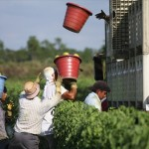

“I’ll be able to be a voice for the other workers.”

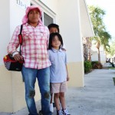

“For the first time in the 10 years of my son’s life, my wife and I are able to eat breakfast with him and walk him to school.”

“For me the most important thing is respect. Now it feels calmer and better at work.”

The Fair Food Program Talking Points
-What is the Fair Food Program?
The Fair Food Program is a farm worker and consumer-driven initiative consisting of a wage increase supported by a price premium (“penny per pound”) paid by corporate purchasers of Florida tomatoes, and a human-rights-based Code of Conduct, applicable throughout the Florida tomato industry. The price premium and the Code of Conduct, which were developed by tomato workers, growers, and corporate buyers in a groundbreaking collaboration, form the foundation for a new model of social accountability.

-Why the Fair Food Program?
The Fair Food Program provides an opportunity for corporations to bring their own considerable resources to the table—their funds and market influence—to help forge a structural, sustainable solution to a human rights crisis that has persisted on U.S. soil for far too long. In the process, the Fair Food Program will help build the foundation for a stronger Florida tomato industry that can differentiate its product in produce aisles and restaurants on the basis of a credible claim to social responsibility.

-What are the major elements of the Fair Food Program?
· A pay increase supported by the price premium Participating Buyers pay for their tomatoes;
· Compliance with the Code of Conduct, including zero tolerance for forced labor and systemic child labor;
· Worker-to-worker education sessions conducted by the CIW on the farms and on company time to ensure workers understand their new rights and responsibilities;
· A worker-triggered complaint resolution mechanism leading to complaint investigation, corrective action plans, and, if necessary, suspension of a farm’s Participating Grower status, and thereby its ability to sell to Participating Buyers;
· A system of Health and Safety volunteers on every farm to give workers a structured voice in the shape of their work environment;
· Specific and concrete changes in harvesting operations to improve workers’ wages and working conditions, including an end to the age-old practice of forced overfilling of picking buckets (a practice which effectively denied workers’ pay for up to 10% of the tomatoes harvested), shade in the fields, and time clocks to record and count all compensable hours accurately.
· Ongoing auditing of the farms to insure compliance with each element of the FFP.

Talking Points Continued
How does the Premium (“Penny per Pound”) reach the workers?
The Fair Food Program Premium is passed down along the supply chain—from the retail level to the grower level—and ultimately is added as a bonus to workers’ paychecks as part of the grower's regular payroll process. The Fair Food Program bonus is clearly marked as a separate line item on the worker's paystub. Over $4 million in Fair Food Program Premiums have been paid out since January 2011. These payments are ongoing, and as more buyers join the program, the bonuses workers receive will grow commensurately. The Fair Food Program Premium payment mechanism for buyers varies. Some have elected to fold the Fair Food Program Premiums into the final price they pay for their produce, akin to fair trade premiums, while other buyers issue separate checks directly to participating Florida tomato growers that reflect the amount and variety of tomatoes purchased.
Are the Fair Food agreements legally binding?
Yes, the Fair Food agreements—between the CIW and retailers, and the CIW and growers—are legally enforceable by the CIW.
Which corporations have signed-on to the Fair Food Program?
Yum Brands- Taco Bell (2005), McDonald’s (2007), Burger King (2008), Subway (2008), Whole Foods Market (2008), Bon Appétit Management Company (2009), Compass Group (2009), Aramark (2010), Sodexo (2010), Trader Joe’s (2012), Chipotle Mexican Grill (2012), and Walmart (2014) are participating in the Fair Food Program.

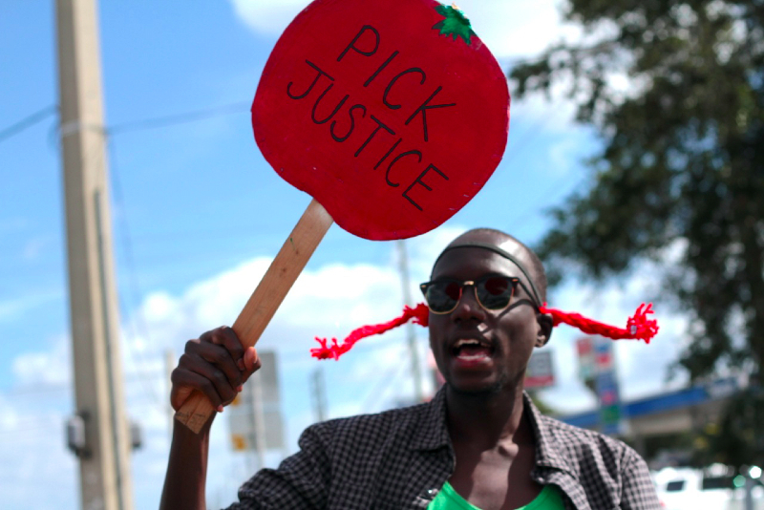
How You Can Support the Fair Food Program
Although the Fair Food Program has been an enormous success throughout the country, farm workers in Immokalee still need support from partners and allies in order to continue their forward movement. There are a variety of ways in which individuals and organizations can show solidarity for the Fair Food Program and for the Coalition of Immokalee Workers.
-EQUIP: Download, print, and take a letter to a Wendy’s, Publix Supermarket, Stop and Shop Supermarket, Giant Supermarket, or Kroger near you. Drop it off with the store manager to let these corporations know that people across the country want them to get on board with the Fair Food Program.
- Wendy’s Letter: http://ciw-online.org/wp-content/uploads/13WendysLTR.pdf
- Publix Letter: http://ciw-online.org/wp-content/uploads/13PublixLTR1.pdf
- Stop and Shop: http://ciw-online.org/wp-content/uploads/12SSLTR.pdf
- Giant: http://ciw-online.org/wp-content/uploads/12GiantLTR.pdf
- Kroger: http://ciw-online.org/wp-content/uploads/12KrogerLTR.pdf
-EDUCATE: Take the Fair Food Program talking points (Pages 5-6) and educate your community about the importance of the Fair Food Program. Host a house party, speak to your local church congregation, or hand out flyers outside one of the above stores. The more people know, the more likely they are to act!
-MOBILIZE: Participate in an action in front of a Publix, Stop and Shop, Giant, Kroger, or Wendy’s. www.nfwm.org will keep you up-to-date on actions across the country. Call the company’s headquarters and tell them why their company needs the Fair Food Program. Be on the lookout for CIW-led actions and events, and participate often! Our solidarity makes the farm worker movement stronger.
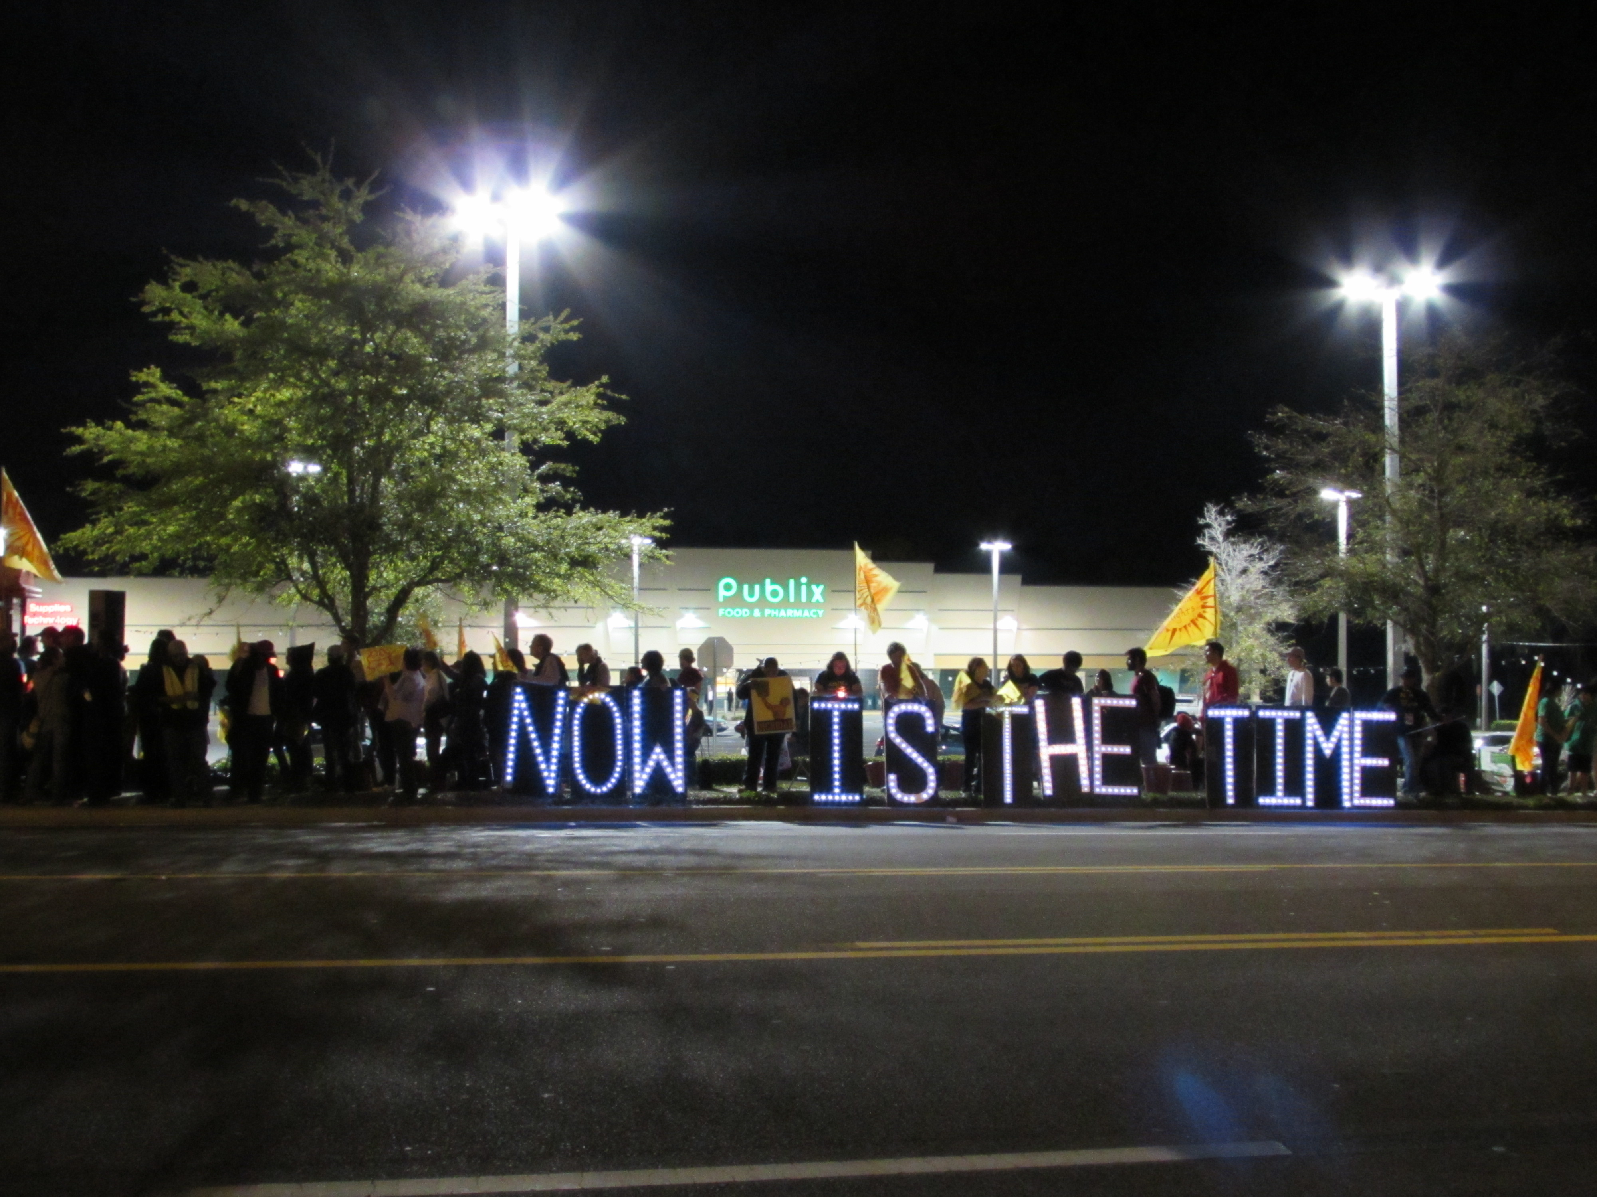

Faith and Farm Workers
Since the days of Cesar Chavez and the birth of the United Farm Workers, the faith community and the farm worker movement have been intertwined. There is a clear link between our calling as leaders of faith and the need to support justice for the dispossessed men, women and children who harvest our food. CIW has worked with the National Council of Churches, the Office of the General Assembly of the PCUSA, and the National Farm Worker Ministry in demanding that Wendy’s join the Fair Food Program. They have been joined by United Methodist Women in pressuring Publix to stand up for Fair Food. The combined voices of people of faith is a wave of justice that cannot be stopped. We have the responsibility to stand up to inequalities without turning a blind eye.
Without the religious support it would have been impossible to win our campaigns.
-Arturo Rodriguez, President, United Farm Workers.

When everyone else said no, that we couldn’t change companies and organize farm workers, [the faith community] said yes. Without the church, FLOC would not exist.
-President Baldemar Velasquez, Farm Labor Organizing Committee

